「以下為範例出題格式，請各委員出題時，請以下列格式繕打，切勿變更其格式，謝謝！」
- 關於Roach formula的敘述，下列何者正確？
  - 是根據TRUS biospy得到的病理結果與治療前PSA和Gleason score之間的關係求得
  - Extracapsular extension之機率= 2/3 PSA + (Gleason score - 6) x 10
  - Seminal vesicle involvement之機率= PSA + (Gleason score - 3) x 10
  - Lymph node positive之機率= 2/3 PSA + (Gleason score - 6) x 10
    - B (Prostate, Roach formula)
      - 易
        - Perez and Brady’s Principle of Radiation Oncology, 5th ed. Ch.62, p1446
          - p 1446 Roach proposed a formula based on analysis of RP specimens to estimate the probability of extracapsular extension (ECE+) and seminal vesicle involvement (SV+):
ECE+ = 3/2 PSA + (Gleason score - 3) × 10
SV+ = PSA + (Gleason score - 6) × 10
- 關於PSA動力學(dynamics)與攝護腺癌(prostate cancer)的關係，下列何者有誤？
  - 可以用來輔助鑑別攝護腺癌(prostate cancer)與良性攝護腺腫大(BPH)。
  - Free PSA/total PSA比值大於0.2，代表罹患攝護腺癌的可能性較高。
  - PSA density：每公克攝護腺組織有大於0.15 ng/ml的PSA，代表惡性的可能性較高。
  - PSA velocity在診斷是否罹患攝護腺癌的角色尚未確定。
    - B (Prostate, PSA dynamics and diagnosis)
      - 中等
        - Perez and Brady’s Principle of Radiation Oncology, 5th ed. Ch.62, p1448-9
          - P.1449 a ratio of free to total PSA of ≤0.2 was most likely associated with prostate cancer, and with higher percentages with benign prostatic hypertrophy.
- 關於攝護腺癌(prostate cancer)治療時的器官移動(organ motion)問題，下列何者為誤?
  - Interfraction prostate motion在anterior-posterior方向最大，在lateral方向最小，主要受到rectum是受到rectum的影響。
  - Intrafraction prostate motion較不顯著，但在anterior與superior方向移動較大。
  - Bony landmark較能正確反應攝護腺的位置。
  - Interfraction prostate motion是造成治療不確定性(uncertainty)最主要的因素，也是目前發展影像導引放射治療(IGRT)最想要解決的問題。
    - C (Prostate, organ motion and IGRT)
      - 中等
        - Perez and Brady’s Principle of Radiation Oncology, 5th ed. Ch.62-63, p1461-2, 1486
          - P.1486 The interfractional three-dimentional (3D) displacements of the prostate and bony anatomy were 5.6 and 4.4 mm prior to localization and 2.8 and 4.4 mm after postlocalization adjustments, respectively, suggesting that bony anatomy does not accurately reflect the position of the prostate.
- 關於RTOG 9408的敘述，下列何者為誤?
  - 主要探討攝護腺癌low- to intermediate risk group之病人接受放射線治療時，合併使用短期雄性素阻斷治療(short-term androgen deprivation therapy, ST-ADT)與不合併使用兩組之間的存活分析。
  - 在合併使用ST-ADT的這組，在治療前以及治療中各給予兩個月的雄性素阻斷劑。
  - 結果發現，使用ST-ADT這組的十年整體存活率(overall survival)與沒有使用這組相比，有顯著差異。
  - 且ST-ADT對於整組病人(不管low-或intermediate risk group)皆有相同效果。
    - D (Prostate, short term hormone therapy)
      - 中等
        - Jones CU, N Engl J Med. 2011 Jul 14;365(2):107-18. "Radiotherapy and short-term androgen deprivation for localized prostate cancer."
          - Results: Reanalysis according to risk showed reductions in overall and disease-specific mortality primarily among intermediate-risk patients, with no significant reductions among low-risk patients.
- 關於RTOG 9202的敘述，下列何者為正確?
  - 主要探討攝護腺癌high risk group之病人接受放射線治療時，合併使用長期雄性素阻斷治療(long-term androgen deprivation therapy, LT-ADT) 與不合併使用兩組之間的存活分析。
  - 在合併使用LT-ADT的這組，在治療前以及治療中各給予兩個月的雄性素阻斷劑，接著在治療後再持續給予二十四個月。
  - 結果發現，使用LT-ADT這組的十年整體存活率(overall survival)與ST-ADT這組相比，有顯著差異。
  - 在亞型分析(subgroup analysis)中，Gleason score 8-10使用LT-ADT有沒有好處。
    - B (Prostate, long term hormone therapy)
      - 難
        - (1) Perez and Brady’s Principle of Radiation Oncology, 5th ed. Ch.63, p1494; (2) Horwitz EM, J Clin Oncol. 2008 May 20;26(15):2497-504. "Ten-Year Follow-Up of Radiation Therapy Oncology Group Protocol 92-02: A Phase III Trial of the Duration of Elective Androgen Deprivation in Locally Advanced Prostate Cancer."
          - (1) After RTOG 8610 demonstrated that short-term AST was beneficial, it served as the control arm in RTOG 9202, a phase III trial that sought to answer whether the addition of 24 months of adjuvant AST could improve outcome in high-risk patients. After a median follow-up of 5.8 years, the long-term AST arm had superior 5-year PSA control (72.0% vs. 44.5%; p <0.0001), prostate cancer-specific survival (94.6% vs. 91.2%; p = 0.006), but not overall survival. On subgroup analysis, long-term AST significantly improved overall survival and cause-specific survival in the patients with Gleason score 8 to 10, whereas no advantage was seen in Gleason score 2 to 7 disease.
(2)Abstract: PATIENTS AND METHODS: Prostate cancer patients with T2c-T4 prostate cancer with no extra pelvic lymph node involvement and prostate-specific antigen (PSA) less than 150 ng/mL were included. All patients received 4 months of goserelin and flutamide before and during RT. They were randomized to no further ADT (short-term ADT [STAD] + RT) or 24 months of goserelin (long-term ADT [LTAD] + RT). A total of 1,554 patients were entered. RT was 45 Gy to the pelvic nodes and 65 to 70 Gy to the prostate. Median follow-up of all survival patients is 11.31 and 11.27 years for the two arms.
RESULTS: At 10 years, the LTAD + RT group showed significant improvement over the STAD + RT group for all end points except overall survival: disease-free survival (13.2% v 22.5%; P < .0001), disease-specific survival (83.9% v 88.7%; P = .0042), local progression (22.2% v 12.3%; P < .0001), distant metastasis (22.8% v 14.8%; P < .0001), biochemical failure (68.1% v 51.9%; P <or= .0001), and overall survival (51.6% v 53.9%, P = .36). One subgroup analyzed consisted of all cancers with a Gleason score of 8 to 10 cancers. An overall survival difference was observed (31.9% v 45.1%; P = .0061), as well as in all other end points herein.
- 關於SWOG 8794/ RTOG 9019/ INT 0086的敘述，下列敘述何者為誤?
  - 主要探討攝護腺癌病患接受radical prostectomy後，具有攝護腺外侵犯(extraprostatic disease, pT3)特徵的病人，接受輔助性放射治療(adjuvant radiation therapy)與不接受兩組之間的存活分析。
  - 病人至少要符合一個特徵：extracapsular extension (ECE), seminal vesicle invasion (SVI), surgical margin positive。
  - 在追蹤10.6年後，整體存活率(overall survival)和遠端轉移無病存活率(metastasis-free survival)相較於對照組僅有趨勢上(trend)的增加，但追蹤12.7年後兩者有顯著增加。
  - 接受放射線治療這組病人的生活品質較對照組差。
    - D (Prostate, Adjuvant radiation therapy)
      - 難
        - (1) Perez and Brady’s Principle of Radiation Oncology, 5th ed. Ch.63, p1498; (2)Follow-up 10.6 yr: Thompson IM Jr, JAMA. 2006 Nov 15;296 (19):2329-35 "Adjuvant radiotherapy for pathologically advanced prostate cancer: a randomized clinical trial." (3)Follow-up 12.7 yr: Thompson IM, J Urol. 2009 Mar;181(3):956-62. "Adjuvant radiotherapy for pathological T3N0M0 prostate cancer significantly reduces risk of metastases and improves survival: long-term followup of a randomized clinical trial."
          - From (3): Global assessment of quality of life, while initially worse in the adjuvant radiotherapy group, became similar by year 2 and was increasingly superior in the radiotherapy group during the following 3 years.
- 一位56歲男性，在今年三月份之健康檢查發現PSA上升至5.6 ng/ml (去年三月份時的PSA為3.8 ng/ml) 經健檢醫師轉介至泌尿科門診求診。在檢查肛門指診時並未現異常，但直腸超音波切片得知其右側攝護腺的為腺癌(adenoncarcinoma)，而發現有腺癌的cores為占所有的1/5，且Gleason score為3+4，下列敘述何者為誤?
  - 該病患之臨床期別為cT1c
  - 根據D’Amico的危險性分類為intermediate-risk group
  - 根據UCSF的作法，將percentage of positive cores視為risk factors之一，該病人應屬於favorable-intermediate risk group
  - 同上，若將PSA velocity考慮進去，該病人為unfavorable-intermediate risk group。
    - D (Prostate, Salvage radiation therapy)
      - 難
        - Perez and Brady's Principle of Radiation Oncology, 5th ed. Ch.63, p 1483-4
          - P 1484: In summary, PSA velocity (>2 ng/mL per year) and PPC (>50%) have further refined our prognostic precision in addition to the traditional predictive factors (pretreatment PSA, Gleason score, clinical T stage). At the University of California–San Francisco (UCSF), the presence of either in intermediate-risk patients, as defined by the D'Amico classification, are considered as unfavorable intermediate- or high-risk disease.
- 承上題，病患與家人再三考慮後，決定接受radical prostectomy手術。術後病理證實為腺癌(adenocarcinoma)，pT2bN0，Gleason 4+3，但沒有ecxtracapsular extension (ECE)、seminal vesicle invasion (SVI)且手術邊緣皆很乾淨。病患在持續在泌尿科門診追蹤，每三至六個月定期檢驗 PSA。下列敘述何者為誤?
  - 追蹤術後PSA上升至0.18 ng/ml，而半年前檢驗時為0.12 ng/ml，仍可以持續觀察。
  - 術後追蹤PSA上升為0.4 ng/ml，而半年前檢驗時為0.18 ng/ml，應即早接受放射線治療，會有較好之預後。
  - 在Stephenson的研究中，術後發生biochemical failure的病人，其術後病理為positive margin者比negative margin者預後要差。
  - 等PSA上升大於2 ng/ml時才接受放射線，其預後非常差。
    - C (Prostate, Salvage radiation therapy)
      - 難
        - Perez and Brady's Principle of Radiation Oncology, 5th ed. Ch.63, p 1499
          - P 1499: In a multi-institutional study, Stephenson et al. reported on the outcomes and prognostic factors of 501 men who had salvage radiotherapy after a biochemical recurrence. Multivariate analyses demonstrated that Gleason score of 8 to 10, preradiotherapy PSA >2 ng/mL, negative margins, PSA-DT ≤10 months, and seminal vesicle invasion were associated with PSA progression.
- 關於睪丸癌(Testicular cancer)的敘述，下列何者為正確?
  - 有癮睪症(cryptorchidism)病史者，得到睪丸癌的機率為一般人之四倍
  - 與免疫低下有關，是僅次於卡波西氏肉瘤(Kaposi’s sarcoma)第二常見的愛滋病相關惡性腫瘤(AIDS-linked malignancy)。
  - Intratubular germ-cell neoplasia (IGCN)為所有生殖細胞瘤(germ cell tumor)之前身。
  - 精母細胞瘤(seminoma)的好發年齡較非精母細胞瘤(nonseminoma)病人早約十年。
    - A (Testis)
      - 難
        - Perez and Brady's Principle of Radiation Oncology, 5th ed. Ch.64, p 1503-1504
          - P 1504 (B) Testicular tumors represent the third most common AIDS-linked malignancy following Kaposi's sarcoma and non-Hodgkin's lymphoma, with a prevalence of 0.2% compared with 0.004% in the general male population
(C) There is strong evidence that IGCN is a precursor lesion of all types of germ-cell tumors except spermatocytic seminoma and infantile testicular tumors.
(D) Nonseminomas have an age-specific incidence peak 10 years earlier than that of seminomas.
- 關於經母細胞瘤(pure seminoma)之處置，下列何者有誤?
  - 經radical inguinal orchiectomy之後若為pT1-2N0，且serum marker正常者，可以直接觀察。
  - 經radical inguinal orchiectomy之後，且serum marker正常者，但在影像學檢查發現在主動脈旁有一顆淋巴轉移約3cm，該分期為stage IIB，應接受術後放射線治療。
  - 上述放射線治療之範圍，應包括主動脈旁(paraaortic)及同側髂骨淋巴結(ipsilateral iliac lymph nodes)。
  - 若已發生遠端轉移者，其別為stage III，轉移至脾臟者為good risk，主要治療為化學治療，Etoposide/Ciplatin x4或Bleomycin/Etoposide/Cisplatin x3。
    - D (Testis)
      - 易
        - Perez and Brady’s principles and Practice of radiation Oncology Chapter 64, p1507 Table 64.7
          - The factors most strongly associated with a poor prognosis were mediastinal primary, nonpulmonary visceral metastases, or the presence of grossly elevated tumor markers (AFP >10,000 ng/mL, HCG >50,000 IU/L or lactate dehydrogenase [LDH] >10 × normal).
- 下列有關Penile cancer之敘述，何者不適當？
  - Circumcision performed early in life protects against penile cancer
  - The glans and the prepuce were the predominant sites of the primary lesion, whereas tumors of the shaft were rare
  - Inguinal lymph nodes are palpable on presentation in 30% to 45% of patients, but only half contain tumor
  - Distant metastases are common, even in patients without inguinal lymph-node involvement
    - D
      - 易
        - Halperin EC, Perez CA, Brady LW, eds. Principles and Practice of Radiation Oncology, 5th ed. 2008: 1519-1521 (Chapter 65).
          - Distant metastases are uncommon (about 10%), even in patients with advanced locoregional disease, and usually occur in patients with inguinal lymph-node involvement
- 根據以往的研究報告，第一期/第二期陰莖癌患者經體外放射治療後，局部腫瘤控制率和陰莖保留率分別為：
- 局部腫瘤控制率75-100%; 陰莖保留率80-100%
- 局部腫瘤控制率75-100%; 陰莖保留率60-80%
- 局部腫瘤控制率50-75%; 陰莖保留率60-80%
- 局部腫瘤控制率50-75%; 陰莖保留率40-60%
    - A
      - 中
        - Halperin EC, Perez CA, Brady LW, eds. Principles and Practice of Radiation Oncology, 5th ed. 2008: 1528 (Chapter 65, Table 65.11).
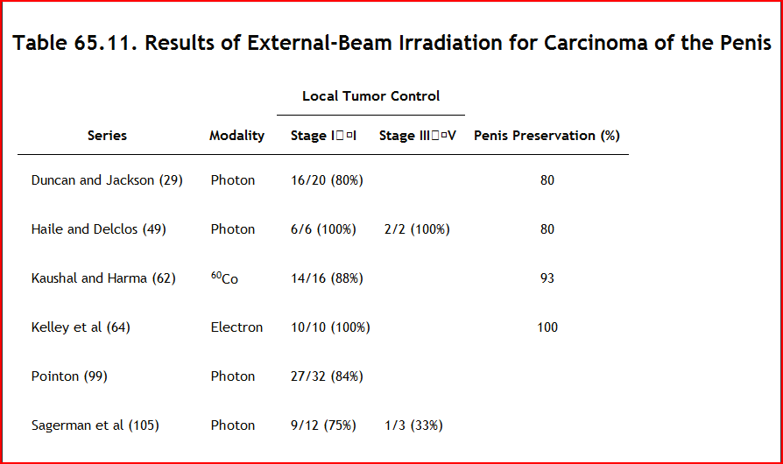
          - .

- 根據以往的研究報告，膀胱癌患者經膀胱保留治療後，五年的膀胱保留率約為多少？
- 25% to 32%
- 38% to 45%
- 51% to 58%
- 64% to 71%
    - B
      - 易
        - Halperin EC, Perez CA, Brady LW, eds. Principles and Practice of Radiation Oncology, 5th ed. 2008: 1431 (Chapter 61, Table 61.12).
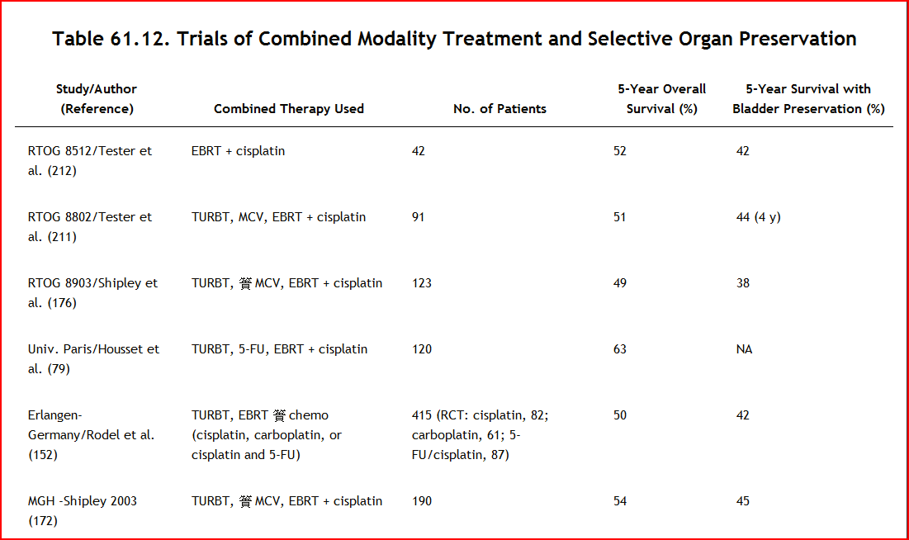

- Among the following description about superficial low-grade tumors (Ta, T1), which one is wrong？
    - Such lesions have about 70% incidence of local recurrence, and 50% have disease progression following transurethral resection of the bladder
    - Approximately one-third of the local recurrent lesions are multiple
    - Tumor progression to muscle-invasive disease at 5 years has been reported in nearly 5%
    - Death from bladder cancer is twice as common in patients with T1 as opposed to Ta disease
    - C
      - 中等
        - Halperin EC, Perez CA, Brady LW, eds. Principles and Practice of Radiation Oncology, 5th ed. 2008: 1412-1413 (Chapter 61).
          - Tumor progression to muscle-invasive disease at 5 years following the diagnosis of superficial low-grade tumors has been reported in nearly 15% of these patients.

- 下列有關膀胱癌的敘述，何者有誤？
- Bladder cancer is more common in males than in females
- Bladder cancer in North America and Europe are transitional cell carcinomas in more than 90% of cases
- Bladder cancer in North Africa is associated with bilharziasis and is primarily adenocarcinoma
- The strongest etiologic risk is the use of tobacco, which is responsible for about 50% of cases of bladder cancer
    - C
      - 易
        - Halperin EC, Perez CA, Brady LW, eds. Principles and Practice of Radiation Oncology, 5th ed. 2008: 1412 (Chapter 61).
          - Bladder cancer in North Africa is associated with bilharziasis and is primarily (more than 50%) squamous cell carcinoma.

